Traditional English Children’s Games

1. Leapfrog
One child puts their hands on the ground and tenses their legs. Another child then runs and uses their hands to push themselves over the first child, spreading their legs and leaping over the first child. For more fun, several children can be in a line, all with their hands on the ground. Then, one child leaps over all the other children, one at a time.

2. Hopscotch
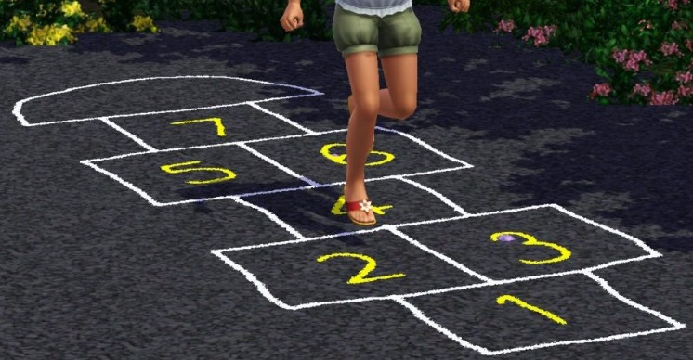
Use chalk to draw ten connected sections on the ground, and number them. Each player has a “marker”, such as a stone. The first player stands behind the starting line and throws his stone in square one. Hop over square one to square two and then continue hopping to square ten, turn around, and hop back again. Pause in square two to pick up the stone, hop in square one, and out. Then throw the stone in square two. Now repeat the whole hopping process, but not including square two. The sequence continues until section number 10 (the last section). Jump on one foot if there is only one section alone, but if two squares are side-by-side, use both feet. A player must always hop over any square where a stone is. A player is “out” if:
1) the marker doesn’t land in the correct square
2) he steps on a line
3) he loses balance and puts a hand or another foot on the ground
4) he jumps in a square where a stone is
5) he puts two feet on the ground in a single box
The player puts a stone in the square where he or she will continue to play on the next turn, and the next player begins.

3. Blind Man’s Buff

One player is blindfolded and then disoriented by spinning around several times. The other players, who are not blindfolded, call to the “blind man” but keep away from him. In the original game, the blindfolded player was usually buffeted by the other players, hence the word “buff.” If the blindfolded player touches or catches another player, he/she must guess the identity of the captive before the blindfold is removed. If the guess is correct, the captive then takes the blindfold, and he/she then becomes the blindfolded player. If the guess is wrong, the captive is released and the game continues.
4. Jacks
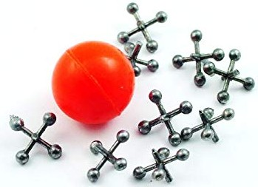
The first player throws the jacks on the ground, then throws the ball in the air. He must then pick up one jack and then catch the ball, with the same hand, before it bounces twice. The player transfers the jack to his other hand, leaving his hand free to play again. He now throws the ball again, but this time, he must pick up two jacks before the ball bounces a second time. For each turn, the number of jacks increases by one. A player stops his turn if:
1) he doesn’t catch the ball before it bounces twice
2) he doesn’t collect the correct number of jacks
3) he drops a jack
When the turn comes back to him, he must continue to play from the same level as before. The player who reaches the highest number of jacks wins the game.


5. Marbles
Draw a circle, about 1 meter wide, on the ground. Each player chooses a “shooter marble” - this should be bigger than the other marbles. Put about 10 ordinary marbles in the ring. When it’s your turn, kneel outside the ring and flick your shooter marble out of your fist with your thumb, trying to push other marbles out of the ring. If you succeed, keep them and have another turn. If you don’t knock any marbles out of the ring, the next player takes their turn. Continue until the ring is empty. The winner is the person with the most marbles at the end of the game.

6. Hide & Seek
One player is “It”, and he covers his eyes and counts to ten (or maybe 20, or maybe 100), slowly and loudly. The other players run away and hide. When “It” finishes counting, he opens his eyes and says “Ready or not, here I come!”. He then tries to find the other players (he “seeks” them). The first player to be found is “It” in the next game, and the last one to be found is the winner.
